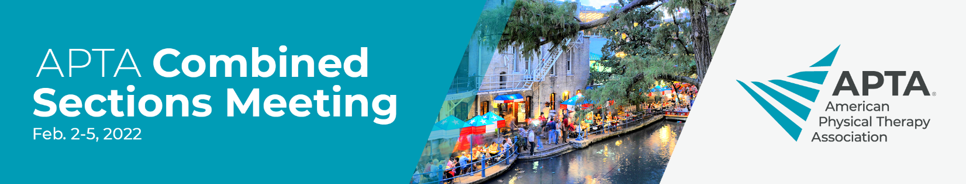

Dear <supervisor’s name>,
I am requesting the opportunity to attend the American Physical Therapy Association's Combined Sections Meeting, the largest physical therapy conference in the country, Feb. 2-5, in San, Antonio, Texas.

Programming is provided by all 18 APTA specialty sections, and topics will be current, research-focused, and will give me relevant, actionable knowledge. I will be able to earn up to 1.8 CEUs, view over a thousand posters, and network with others in attendance. I also will have access to the on-demand content, featuring over 100 sessions, available March 1-31, although no additional CEUs will be earned.

If submitting the request before Nov. 3, please use:

If I register by the early bird deadline of Nov. 3, I’ll receive the best available rate. The early bird rate is in the cost calculations below:

If submitting between Nov. 4 and Dec. 16, please use:

If I register by the advance rate deadline of Dec. 16, I will be eligible for a discounted rate. The advance rate is in the cost calculations below:

If submitting after Dec. 16, please use:

Cost calculations:
Registration: <$xxxx>
Round-trip travel: <$xxxx>
Additional transportation: <$xxxx>
Hotel: <$xxxx>
Meals: <$xxxx>
Total: <$xxxx>

Please let me know if you have questions or need additional information to make your decision.

Thank you very much for your consideration.

< your name here>
APTA.org/CSM

