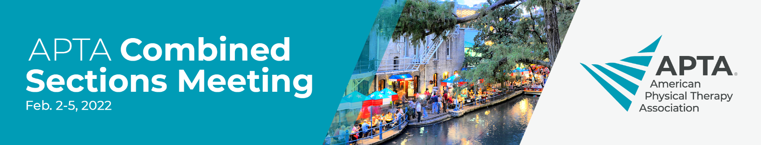

Dear <supervisor’s name>,
This year, APTA is providing an on-demand option for APTA Combined Sections Meeting that will feature over 100 sessions from the in-person event, curated by the 18 APTA specialty sections. Topics will be current, research-focused, and will give me relevant, actionable knowledge.

I am requesting approval to register for APTA CSM on demand. Cost information is below.

If you are requesting permission for APTA CSM on demand with CEUs please use the following and include only the appropriate pricing from the list below:

I also will have the potential to earn up to 1.2 CEUs (12 contact hours) based on the successful completion of posttests.

Pricing:
Nonmember: $600
Member: $360

If you are requesting permission for APTA CSM on demand without CEUs, please include only the appropriate pricing from the below list:

Pricing:
Nonmember: $500
Member: $300
Student: $175

Please let me know if you have questions or need additional information to make your decision.

Thank you very much for your consideration.

< your name here>
APTA.org/CSM

