May 15, 2020

On behalf of the American Speech-Language-Hearing Association (ASHA), the American Physical Therapy Association (APTA), and the American Occupational Therapy Association (AOTA), we write to inform you of the potential negative implications of the transition to new Medicare payment models for skilled nursing facilities (SNFs) and home health agencies (HHAs) that went into effect on October 1, 2019, and January 1, 2020, respectively. The Patient-Driven Payment Model (PDPM) for SNFs and Patient-Driven Groupings Model (PDGM) for HHAs represent a fundamental shift in payment intended to incentivize patient-centered care and mitigate the risk of inappropriate utilization that existed in the legacy payment systems.

ASHA, APTA, and AOTA support the goals of the new payment models but physical therapists, occupational therapists, speech-language pathologists, and therapy assistants report that, as a result of the transition, some SNFs and HHAs are prioritizing profits over patients. While limited data exists, we maintain that such business decisions deserve your attention now in order to mitigate the negative impact on patients and effectuate timely improvements to these payment systems.

ASHA is the national professional, scientific, and credentialing association for 211,000 members and affiliates who are audiologists, speech-language pathologists (SLPs), speech, language, and hearing scientists, audiology and speech-language pathology support personnel, and students.

APTA is an individual membership professional organization representing more than 100,000 member physical therapists (PTs), physical therapist assistants (PTAs), and students of physical therapy. APTA seeks to improve the health and quality of life of individuals in society by advancing physical therapist practice, education, and research, and by increasing the awareness and understanding of physical therapy's role in the nation's health care system.

AOTA is the national professional association representing more than 60,000 occupational therapy practitioners and students of occupational therapy. The science-driven, evidence-based practice of occupational therapy enables people of all ages to live life to its fullest by promoting participation in daily occupations or activities.

Our members work in both SNFs and HHAs providing medically necessary care to Medicare beneficiaries.
Reported examples of inappropriate practices occurring in SNFs and HHAs as a result of implementing PDPM and PDGM include:
- using predictive analytic programs to determine the intensity, frequency, and duration of therapy services provided to patients without allowing members of the interdisciplinary care team to exert their clinical judgment;
- reducing therapy staff, including firing therapists or scaling back hours, which impacts patients’ timely access to care and increases the risks for misidentification of potentially preventable health complications such as aspiration pneumonia or falls;
- requiring therapists to perform services outside of their scope of practice (e.g., requiring SLPs to perform wound care);
- mandating the use of group and concurrent therapy in SNFs when not indicated based on the patient’s presentation and the clinical judgment of therapist(s);
- ignoring or modifying physician orders and/or plans of care to limit or prevent the provision of therapy to patients when medically necessary, including limiting therapy to one discipline when the order/plan of care called for multiple therapy disciplines to provide care in order to meet patient needs and achieve goals;
- limiting admissions to home health from the community given the lower reimbursement based on this admission source;
- discharging patients from home health within the first 30 days because of payment reductions for the second 30-day payment period of the 60-day home health episode;
- misinforming therapists that Medicare does not allow them to perform certain types of treatment (e.g., cognitive treatment) even when state law recognizes the services within their scope of practice;
- failing to provide maintenance therapy services due to a lack of understanding of the Jimmo v. Sebelius settlement and misapplication of Medicare coverage criteria; and
- misinterpreting the use of the clinical categories central to these payment systems to withhold therapy from patients who do not fall into clinical categories that trigger a separate therapy payment, even when the service meets medical necessity criteria.

Our associations stand committed to ensuring all patients retain access to medically necessary therapy services and ensuring all stakeholders understand the impact these business-driven decisions can have on patient outcomes. In addition to the reports above, our members have also reported concerns regarding potentially preventable health care conditions and negative patient outcomes tied to facility and agency protocols that appear to only be tied to the objective of maximizing Medicare reimbursement. Examples of poor outcomes include increases in falls, hospital readmissions, inability to perform activities of daily living (ADLs), urinary tract infections, pressure ulcers, and aspiration pneumonia.

We strongly believe that Medicare beneficiaries and their caregivers deserve to know the facts about Medicare coverage in SNFs and HHAs to address the inappropriate practices and that they have resources to advocate for themselves. We have developed the attached resource on the payment models and would appreciate you sharing it with consumers who may contact you with concerns.

If we can provide additional assistance and support, please do not hesitate to contact us.

- For questions related to speech-language pathology services, contact Sarah Warren, MA, ASHA’s director of health care policy for Medicare, at swarren@asha.org or 301-296-5696.
- For questions related to physical therapy, contact Kara Gainer, APTA’s director of regulatory affairs, at karagainer@apta.org or 703-706-8547.
- For questions related to occupational therapy, contact Jennifer Bogenrief, AOTA’s assistant director of regulatory affairs, at jbogenrief@aota.org or 240-482-4150.
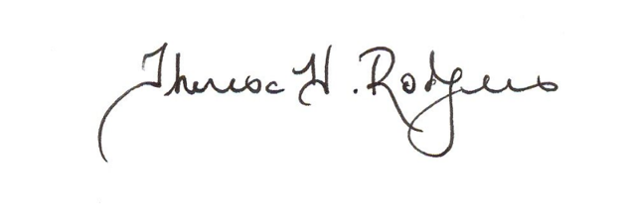
Sincerely,

Theresa H. Rodgers, MA, CCC-SLP
2020 ASHA President
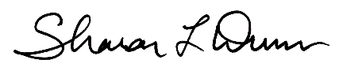

Sharon L. Dunn, PT, PhD
Board-Certified Clinical Specialist in Orthopaedic Physical Therapy
APTA President

Wendy C. Hildenbrand, PhD, MPH, OTR/L, FAOTA
AOTA President

Attachment

